Les meilleurs résultats :
Image 11
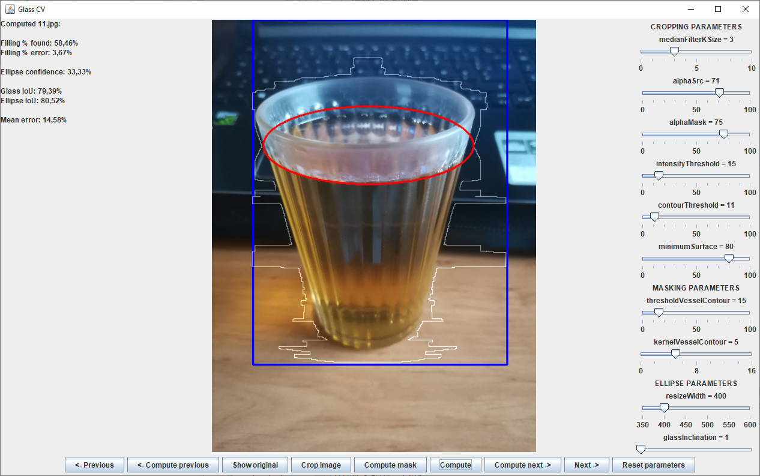
Resultat : ({532.166666666667, 1225.1666666666667},{2315.5, 1279.3333333333335})
middle : {1423.8333333333335, 1252.25}
Angle value : 0.030364496284220388
Filling % found: 58,46%
Filling % via JSON file: 60,69%
Filling % error: 3,67%
Ellipse confidence: 33,33%
Glass IoU: 79,39%
Ellipse IoU: 80,52%
Mean error: 14,58%

Image 20
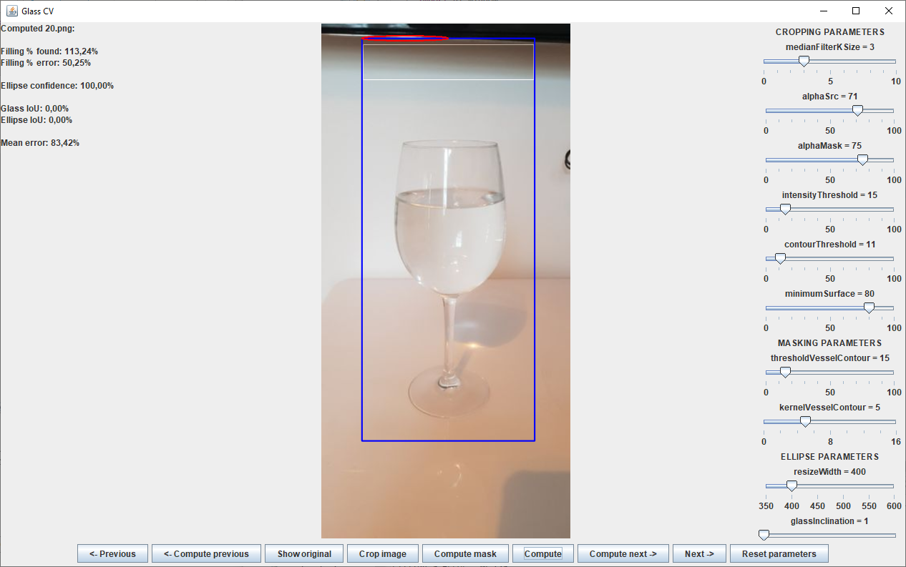

Resultat : ({93.45390070921991, 216.13475177304966},{231.04255319148945, 216.84397163120568})
middle : {162.24822695035468, 216.48936170212767}
Angle value : 0.0051545935225452396
Filling % found: 113,24%
Filling % via JSON file: 75,36%
Filling % error: 50,25%
Ellipse confidence: 100,00%
Glass IoU: 0,00%
Ellipse IoU: 0,00%
Mean error: 83,42%

Image 24
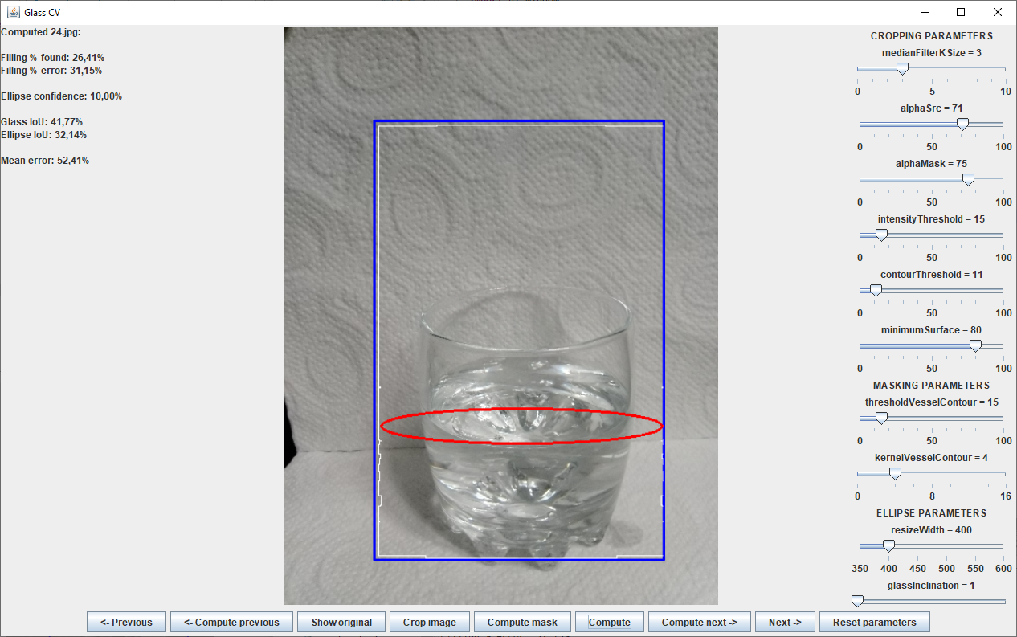

C:\Users\thoma\git\glass-computer-vision2\img\test\24.json
Resultat : ({1099.0, 3078.0},{2799.0, 3068.0})
middle : {1949.0, 3073.0}
Angle value : 0.005882285095392453
Filling % found: 26,41%
Filling % via JSON file: 38,36%
Filling % error: 31,15%
Ellipse confidence: 10,00%
Glass IoU: 41,77%
Ellipse IoU: 32,14%
Mean error: 52,41%

Image 29
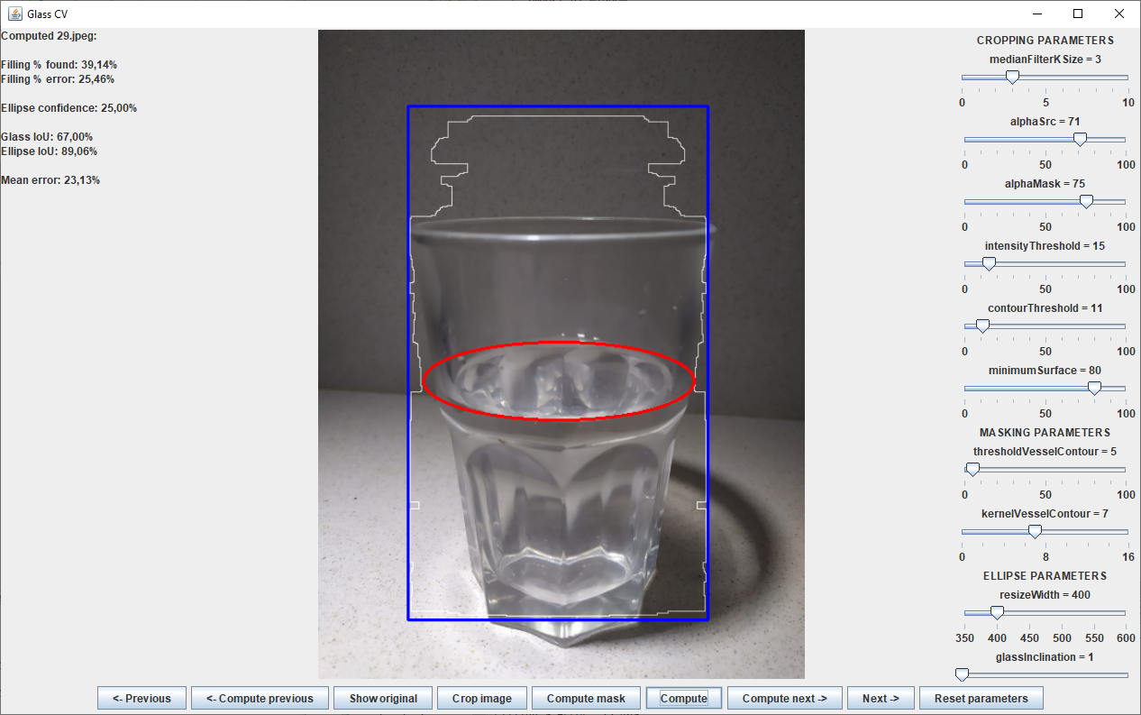
Angle value : 0.018565505922624608
Filling % found: 39,14%
Filling % via JSON file: 52,51%
Filling % error: 25,46%
Ellipse confidence: 25,00%
Glass IoU: 67,00%
Ellipse IoU: 89,06%
Mean error: 23,13%

Image 34
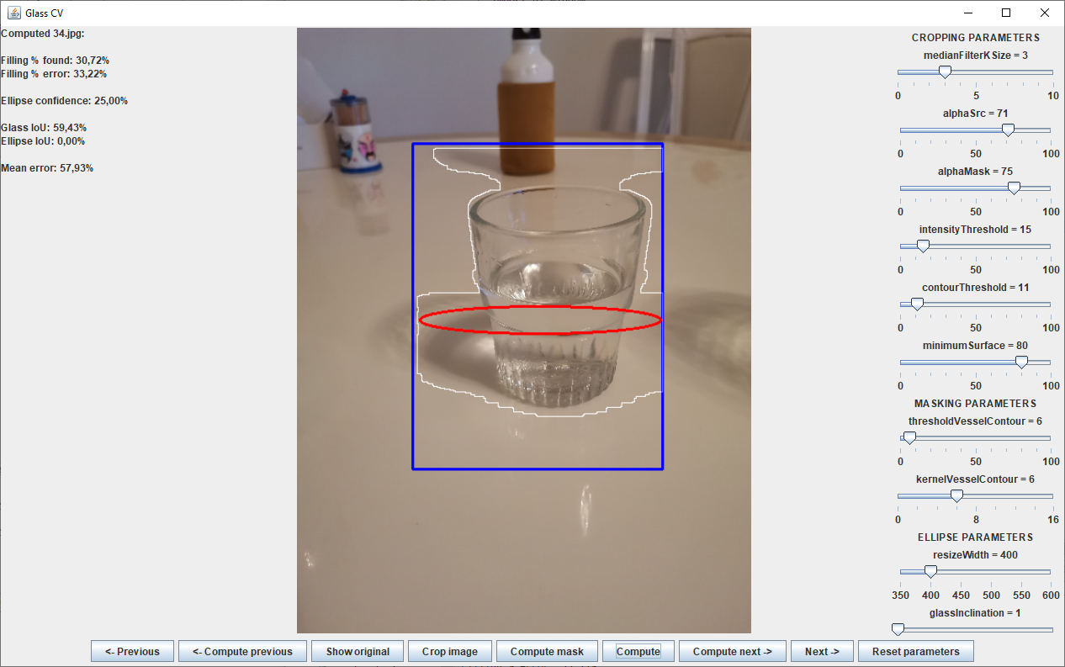
Angle value : 0.02726596845559246
Filling % found: 30,72%
Filling % via JSON file: 46,00%
Filling % error: 33,22%
Ellipse confidence: 25,00%
Glass IoU: 59,43%
Ellipse IoU: 0,00%
Mean error: 57,93%

Image 38
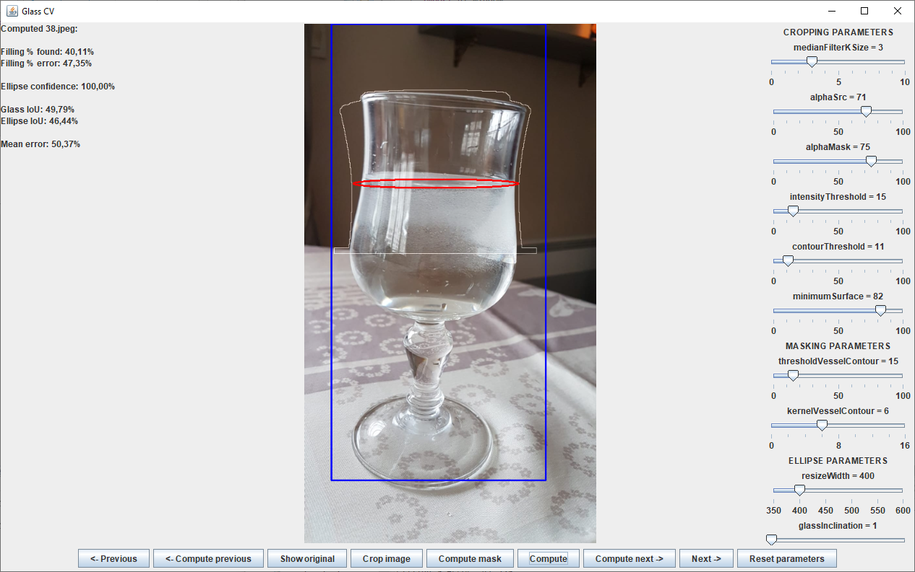
Angle value : 0.03102452500426927
Filling % found: 40,11%
Filling % via JSON file: 76,17%
Filling % error: 47,35%
Ellipse confidence: 100,00%
Glass IoU: 49,79%
Ellipse IoU: 46,44%
Mean error: 50,37%

Image 45
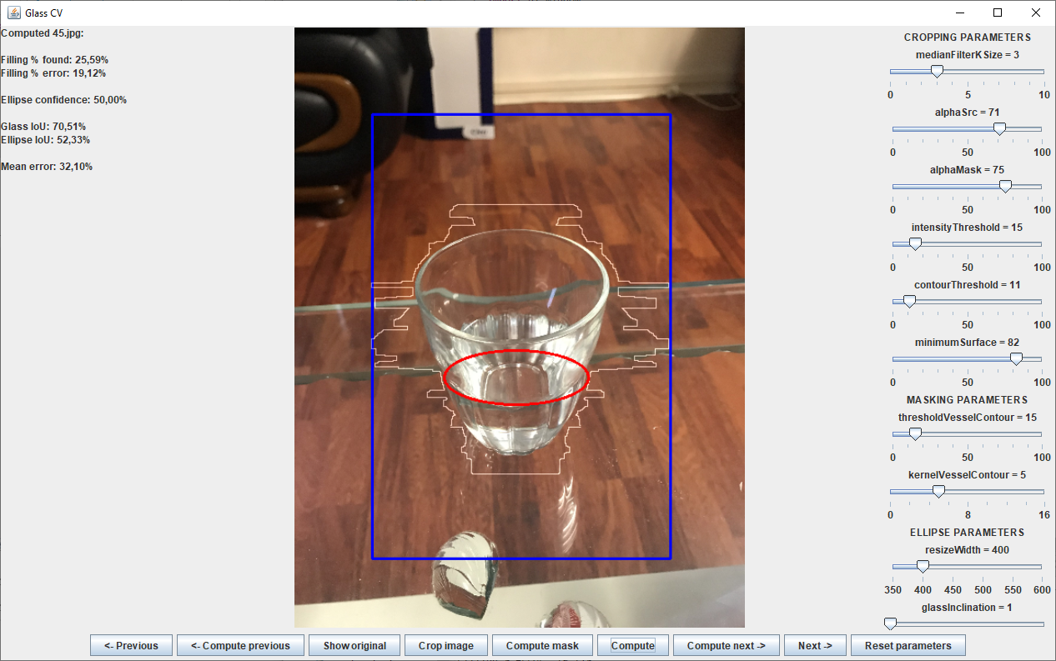
Angle value : 0.12297186956429706
Filling % found: 25,59%
Filling % via JSON file: 21,48%
Filling % error: 19,12%
Ellipse confidence: 50,00%
Glass IoU: 70,51%
Ellipse IoU: 52,33%
Mean error: 32,10%

Image 56
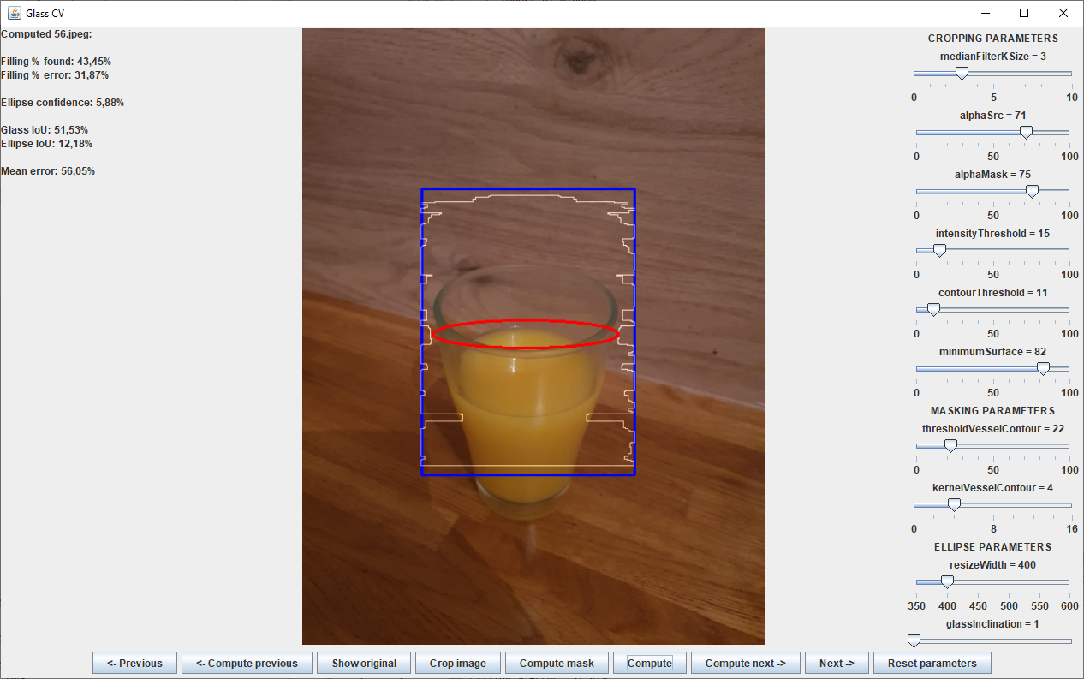
Angle value : 0.5030703287981324
Filling % found: 43,45%
Filling % via JSON file: 32,95%
Filling % error: 31,87%
Ellipse confidence: 5,88%
Glass IoU: 51,53%
Ellipse IoU: 12,18%
Mean error: 56,05%

Image 63
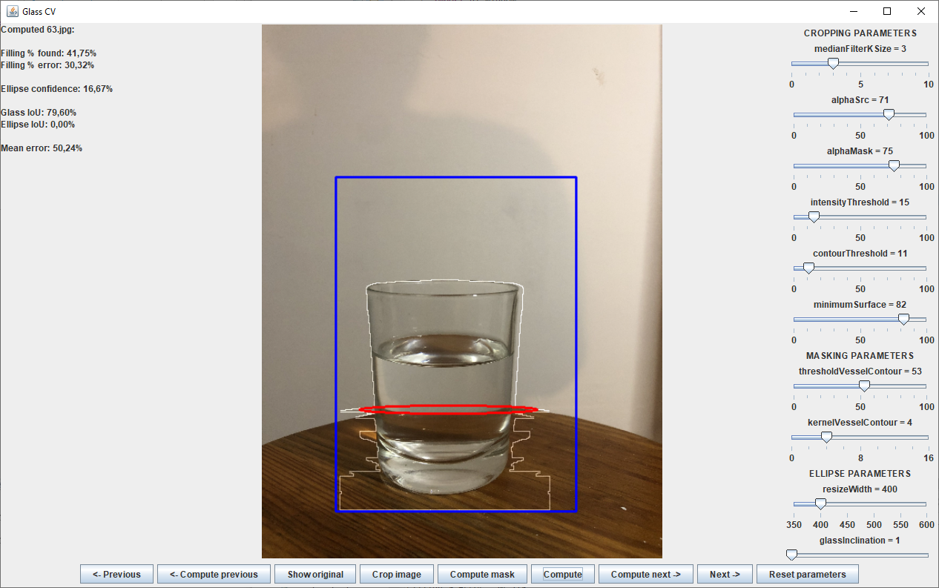
Resultat : ({1879.3650793650793, 2463.4920634920636},{860.3174603174604, 2476.190476190476})
middle : {1369.8412698412699, 2469.84126984127}
Angle value : 0.01246041427401096
Filling % found: 41,75%
Filling % via JSON file: 59,93%
Filling % error: 30,32%
Ellipse confidence: 16,67%
Glass IoU: 79,60%
Ellipse IoU: 0,00%
Mean error: 50,24%

Image 71
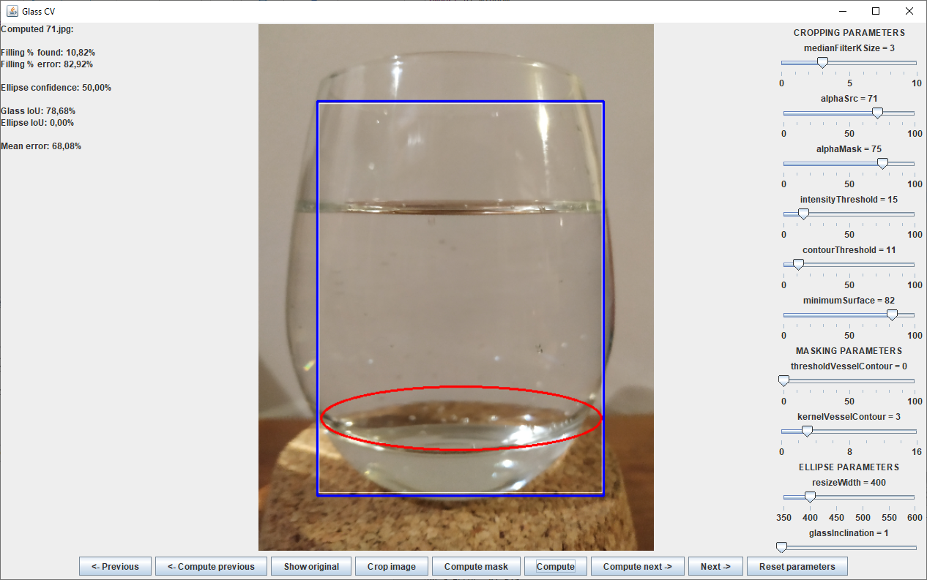
Resultat : ({2633.666666666667, 1423.6666666666667},{287.8333333333335, 1382.0})
middle : {1460.7500000000002, 1402.8333333333335}
Angle value : 0.017760121796570272
Filling % found: 10,82%
Filling % via JSON file: 63,32%
Filling % error: 82,92%
Ellipse confidence: 50,00%
Glass IoU: 78,68%
Ellipse IoU: 0,00%
Mean error: 68,08%

